WorldMap - User interface Design

**Team Passion Fruit**

Jake Horner - x16318711

Ken Dolan - x16312261

Zara O’Brien - x17363043

Robert Roe - x17138752

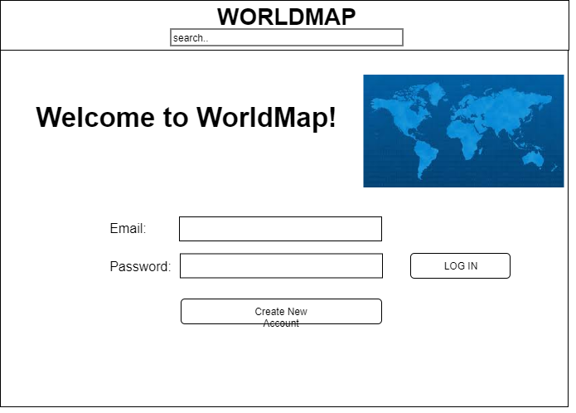

Figure 1

This is the home page of our website. Here you can log into an existing account or create a new account.

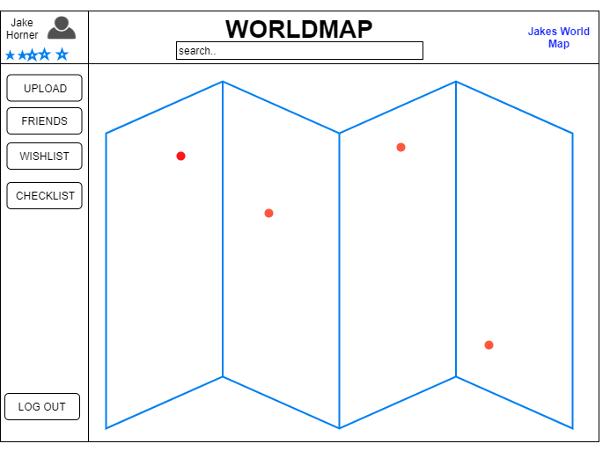

Figure 2

Once you have logged in or set up an account you will see this page which is your own personal WorldMap, here you will see red dots on the map of the world representing the places you have taken pictures and therefore visited.

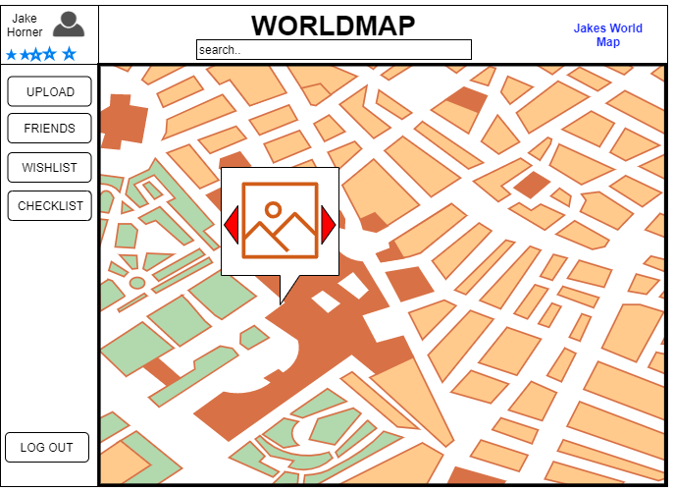

Figure 3

This is the same map as Figure 2 but we have zoomed in using the mouse wheel (while hovering over the map) you can view the photo and its assigned place on the map. If multiple pictures were taken in the same place you can click the arrows to go between the pictures.

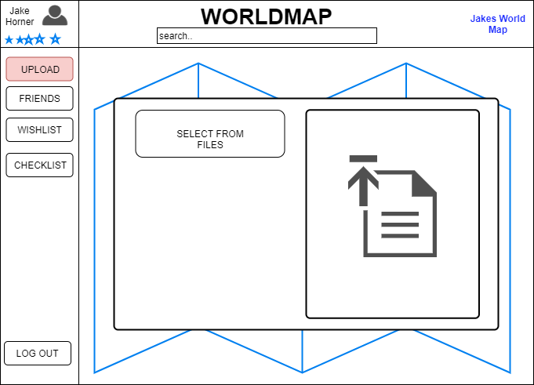

Figure 4

When you click the upload button on the side bar on figure 2, a pop up will come up and you have the ability to drag and drop files onto the screen or choose from the files on your device.

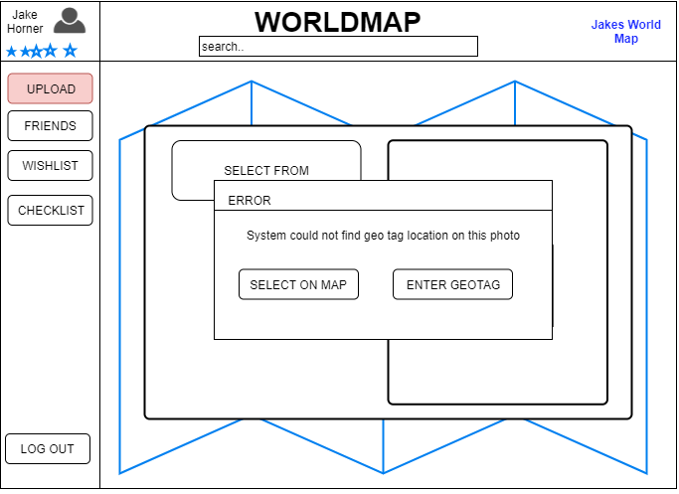

Figure 5

Our system will be able to read the geolocation from the photo, placing it correctly on the map, however in the event that the image does not store geotag location, you can manually input longitude and latitude or be able to select the location on the map.

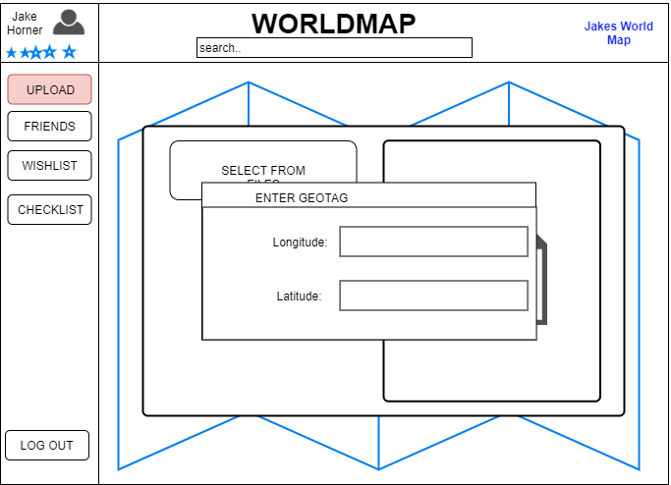

Figure 6

This is how you would manually input the photos location when using the upload button in figure 4.

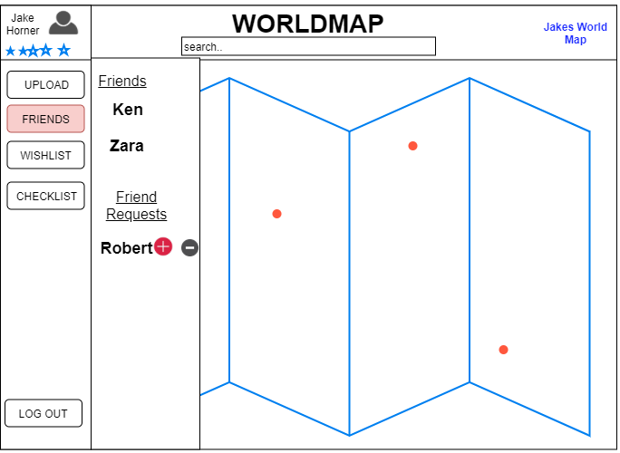

Figure 7

You can add friends to view their WorldMaps by searching for them in the search bar and requesting to be their friend, similarly if someone adds you as a friend you will get a request in the friends section of the website.

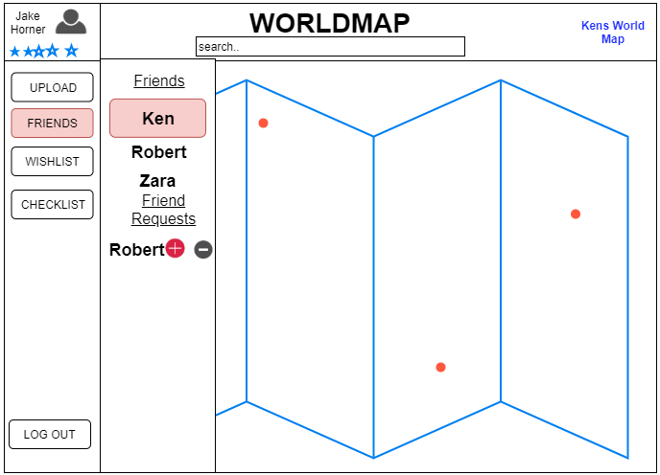

Figure 8

Once you have friends you can view their maps by clicking on their name, in the friends section and their name should appear in the top right in blue as seen in each figure along with their map.

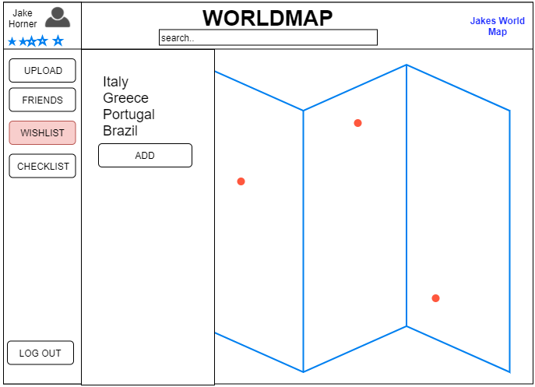

Figure 9

You can store a list of places you wish to travel to in the wishlist section of the sidebar. When pressing the wishlist button a side window will pop up where you can press add to add a new place.

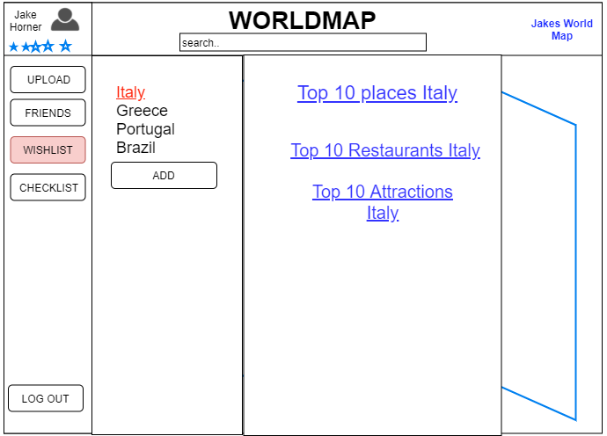

Figure 10

When you press on any of the locations in your wishlist in figure 9, Information related to the location will appear, Including hotel booking and airline information etc

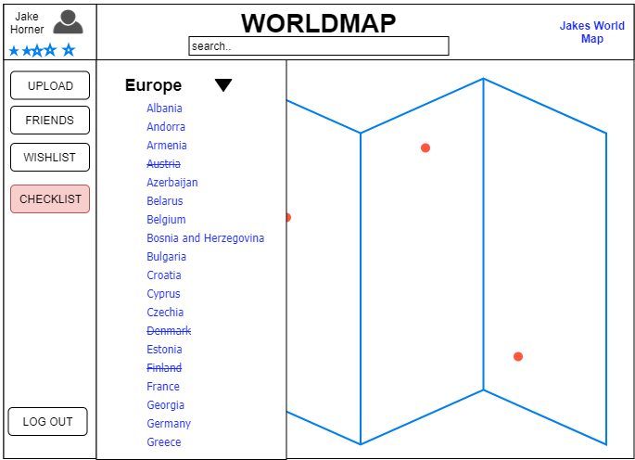

Figure 11

When you upload a photo the system should know from its placement which countries you have visited. The checklist is updated from every photo uploaded.